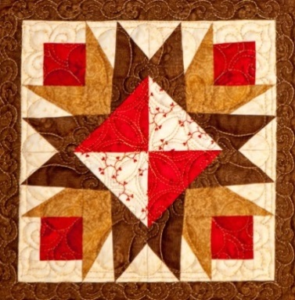
Show Chairperson
Wendy Cockrell
(916) 803-2713
wendy.cockrell@gmail.com

Vendor Chairperson
Cheryl Gaines
1610 Jeffrey Drive
Yuba City, CA 95991
(530) 671-7562
rcgaines@syix.com

“Not your Grandma’s Quilt”
March 21st and 22nd, 2015
Application for Vendor Booth Space
Deadline for Booth Space: December 15, 2014

Please include a brief description of merchandise & photos, if possible, with your reservation check.

Business Name: ________________________________________________________________________
Resale License Number⁺: ________________________ Website: ________________________________
Contact Name: ________________________________________________________________________
Address: ____________________________________ City: _______________ State: _____ Zip: _______
Phone No: _______________________ Cell No: _____________________ Fax: ____________________
E-Mail: ________________________________
Description of Quilt Related Merchandise: __________________________________________________
_____________________________________________________________________________________
__________________________________________________________________________________________________________________________________________________________________________
⁺A copy of your Resale License must be provided showing 441 Franklin Ave, Yuba City, CA 95991 as a business location.

Booth Information
- Single booths are approximately 10’ x 10’, which includes: Two (2) tables, two (2) chairs and electricity.
- Only one (1) vendor allowed in each booth space: Amount Enclosed $_____
_____Single Booth $150* (10x10)
_____ Double Booth $275* (10x20)
* Booth Rentals include Insurance.
_____ Triple Booth $400* (10x30)
_____ # of Additional Tables Needed
_____ # of Additional Chairs Needed

Set-up: Friday, March 20th, 2015, AFTER 3 PM. Take down Sunday, March 22nd, 2015, AFTER 4 PM.
Confirmation and local area information will be sent February 1, 2015.

